a

MINI PRoJECt REPORT

ON

“DESIGN SIMULATION & FABRICATION OF ANTENNA FOR MBAN APPLICATION”

FOR PARTIAL FULFILLMENT
OF THE REQUIREMENTS FOR THE
Mini PROJECT SUBJECT
oF T.E. E&TC – 2019 Course, SPPU, Pune

By Team Members:

PRATHMESH RAMESH KHOSE T190053138
OM DNYANESHWAR SHINDE T190053263
PRATHMESH PRAKASH KALAMKAR T190053227

GUIDE
Ms. Pragtee Tathe

Department Of
Electronics and TELECommunication ENGINEERING
PUNE INSTITUTE OF COMPUTER TECHNOLOGY
PUNE – 43

ACADEMIC YEAR: 2022 - 2023

Department of Electronics and Telecommunication Engineering
Pune Institute of Computer Technology, Pune – 43

CERTIFICATE

This is to certify that the Mini Project report entitled.

“DESIGN SIMULATION & FABRICATION OF ANTENNA FOR MBAN APPLICATION”
has been successfully completed by

PRATHMESH RAMESH KHOSE T190053138
OM DNYANESHWAR SHINDE T190053263
PRATHMESH PRAKASH KALAMKAR T190053227

Is a bona fide work carried out by them under the supervision of Ms. Pragtee Thate and it is approved for the partial fulfillment of the requirements for the Mini Project subject of T.E. E&TC – 2019 Course of the Savitribai Phule Pune University, Pune.

Prof. Prof.
Project Guide HOD, E&TC Dept. of E&TC

Place: Pune
Date:

ACKNOWLEDGEMENT

We would like to express our sincere gratitude to everyone who has contributed to the completion of this project report.

Firstly, we would like to thank our supervisor Ms. Pragtee Tathe, for providing us with invaluable guidance, support, and feedback throughout the entire duration of this project. Her expertise and knowledge were essential in helping us navigate through the challenges we faced, and we are deeply grateful for her time and effort.
We would also like to extend our thanks to the Electronics and Telecommunication Department at Pune Institute of Computer Technology for providing us with the necessary resources and facilities to carry out our research.

We would like to thank the participants (Seniors) who took part in our study, and without whom this project would not have been possible. Their willingness to share their experiences and insights was greatly appreciated.

Lastly, we would like to acknowledge our families and friends for their unwavering support and encouragement, and for their understanding during the times when we needed to focus on our work.

Once again, we express our heartfelt appreciation to everyone who has contributed to this project report.

PRATHMESH KHOSE
OM SHINDE
PRATHMESH KALAMKAR

ABSTRACT
The design simulation of an antenna for MBAN (Medical Body Area Network) application operating at 2.38 GHz with HFSS (High-Frequency Structural Simulator) involves the analysis and optimization of the antenna's performance parameters to ensure reliable communication between medical devices within the body area network. The antenna's design is optimized for the specific frequency range and HFSS protocol to meet the MBAN requirements.
In the simulation, various parameters such as return loss, radiation pattern, and impedance matching are analyzed to ensure the antenna's optimal performance. The simulation uses advanced electromagnetic simulation tools, such as HFSS, to design and optimize the antenna, and the results are analyzed to ensure that the antenna meets the required specifications.
The optimized design of the antenna with HFSS results in improved wireless communication within the MBAN, providing enhanced reliability and reducing the risk of interference from other wireless devices operating in the same frequency band. The proposed antenna design with HFSS enables the deployment of more effective and reliable healthcare solutions.
PRATHMESH KHOSE
PRATHMESH KALAMKAR
OM SHINDE

List of figures:

Sr. No | Figure number and Figure caption | Page no.
1 | BLOCK DIAGRAM OF MICROSTRIP ANTENNA | 15
2 | IMPLEMENTATION OF RECTANGULAR PATCH ANTENNA | 19
3 | TESTING OF SQUARE PATCH ANTENNA | 19
4 | RETURNLOSS GRAPH | 20
5 | BW GRAPH | 20
6 | VSWR GRAPH | 21
7 | PATCH IMPEDANCE GRAPH | 21
8 | FRONT VIEW OF ANTENNA | 22
9 | BACK VIEW OF ANTENNA | 23
10 | FINAL WORKING DIAGRAM | 24
11 | RETURNLOSS ON VNA | 25
12 | VSWR ON VNA | 25
13 | IMPEDANCE ON VNA | 26
14 | SMITHCHART ON VNA | 26

Abbreviations

Symbol/word | Meaning | Remark
HFSS | High-Frequency Structural Simulator
MBAN | Medical Body Area Network
VSWR | Voltage Standing Wave Ratio
εr | Relative permittivity
fr | Resonant frequency of the Microstrip antenna
v0 | speed of light in free space
εo | Permittivity of free space
µ0 | Permeability of free space
Γ | Reflection Coefficient
RL | Return Loss
BW | Band Width
G | Gain
U | Radiation Intensity
D | Directitvity

CONTENTS

 | Abstract |  | i
 | List of Figures |  | ii
 | List of Tables |  | iii
 | Abbreviations |  | iv
1 | Introduction |  | 1-10
 | 1.1 | Background and Context | 1
 | 1.2 | Relevance | 2
 | 1.3 | Literature Survey | 3
 | 1.4 | Motivation | 6
 | 1.5 | Aim of the Project | 7
 | 1.6 | Scope and Objectives
 | 1.7 | Technical Approach
2 | Block Diagram
 | 2.1 | Theoretical background
 | 2.2 | Block diagram
 | 2.3 | Flow chart Algorithm
3 | System Design
4 | Implementation, Testing and Debugging
5 | Results and discussion
 | Conclusions and Future Scope
 | Bill of Material
 | References
 | Datasheets

Feasibility report

Title: Design Simulation And Fabrication Of Antenna For MBAN Application.
Group members:

32236 – Om Shinde
- 32240 –Prathmesh Khose

32136-Prathmesh Kalamkar

Tools required | Testing possibility | Controller | Any Cost
Hardware/components  FR4 material  Connector | Hardware Yes
Software  HFSS(High frequency Structure Simulator) | Software Yes | No need of controller in software
Tools available within campus  or outside | Sensors required | Signal conditioning if any
Campus | No
Applications if any | PCB design and fabrication | Datasheets/ application  notes available
Monitor patients' physiological data in real-time, allowing doctors and healthcare professionals to closely monitor patients' health conditions | Yes
Mechanical design | Enclosure design | Demonstration
Yes |  | Yes , demonstration is possible

CHAPTER 1

Introduction

Background

a)Antenna:
- An antenna is an electrical device designed to transmit or receive electromagnetic waves. It is typically a metallic structure that can convert electrical signals into radio waves, or vice versa.
- Antennas are commonly used in communication systems such as radio, television, mobile phones, and wireless networks.
- They are also used in scientific research, navigation systems, and in the aerospace industry.
- Antennas come in various shapes and sizes depending on their intended use, frequency range, and operating environment.
- They can be designed to radiate electromagnetic energy in specific directions and can be optimized to achieve specific performance characteristics such as gain, bandwidth, and directivity.

b) MBAN:
- MBAN stands for Medical Body Area Network. It is a wireless network that connects medical devices attached to a patient's body for monitoring and diagnostic purposes. T
- The network can be used to monitor various vital signs such as heart rate, blood pressure, and body temperature, and can provide real-time data to healthcare professionals.
- MBAN can be used in various medical applications such as hospitals, clinics, and home healthcare settings.
- It offers several benefits such as continuous monitoring, reduced patient discomfort, and improved patient outcomes.
- The MBAN technology uses low-power wireless communication technology and operates in the frequency range of 2.36 GHz to 2.39 GHz.

Literature Survey / Prior work:

- Types of antennas:
The survey can cover the various types of antennas that are commonly used, including dipole antennas, monopole antennas, patch antennas, helical antennas, and many others.

- Antenna design parameters:
The survey can also include an overview of the parameters that are considered when designing an antenna, such as gain, radiation pattern, bandwidth, impedance matching, and polarization.

- Antenna design techniques:
The survey can cover the different techniques used in antenna design, such as analytical methods, computer-aided design (CAD) tools,HFSS and optimization algorithms.

- Recent developments:
The survey can also include recent developments in antenna design, such as the use of metamaterials, reconfigurable antennas, and antennas for new applications like the Internet of Things (IoT) and 5G networks.

- Applications:
The survey can also discuss the various applications of antennas, including wireless communication systems, radar systems, satellite communication systems, and biomedical applications.

- Challenges and limitations:
The survey can also discuss the challenges and limitations of antenna design, such as the difficulty in achieving wideband performance, the effect of the surrounding environment on antenna performance, and the trade-offs between different performance parameters.

Motivation

The motivation behind the design simulation of an antenna for MBAN (Medical Body Area Network) application is to optimize the antenna design for the specific requirements of the application. MBANs are used for monitoring and diagnosing patients in real-time, and the performance of the antennas used in these systems can have a significant impact on the accuracy and reliability of the data collected.

The simulation of the antenna design allows for a virtual testing environment, where different designs can be evaluated for their performance characteristics such as return loss, radiation pattern, and impedance matching. This helps to identify the best design that can meet the specific requirements of the MBAN application.

Additionally, simulation tools such as HFSS (High-Frequency Structure Simulator) can provide insights into the behavior of the antenna in different environments and operating conditions. This can help to ensure that the antenna will perform reliably in a range of situations, including variations in the patient's movements or changes in the surrounding environment.

By optimizing the antenna design through simulation, it is possible to reduce the time and cost involved in physical prototyping and testing. This can lead to faster development cycles and improved performance of the MBAN system.

In summary, the motivation behind the design simulation of an antenna for MBAN application is to optimize the design for the specific requirements of the application, ensure reliable performance in different operating conditions, and reduce development time and costs.

Aim of The Project

The aim of the design simulation of an antenna for MBAN (Medical Body Area Network) application is to optimize the antenna design for the specific requirements of the application. MBANs are used for monitoring and diagnosing patients in real-time, and the performance of the antennas used in these systems can have a significant impact on the accuracy and reliability of the data collected.

The specific aims of the design simulation of an antenna for MBAN application are:

To optimize the antenna design for the frequency range of 2.36 GHz to 2.39 GHz, which is the frequency band allocated for MBAN applications.

To ensure that the antenna is compact and can be integrated easily into the medical devices or sensors that are attached to the patient's body.

To ensure that the antenna has a high gain and efficiency to ensure reliable communication between the medical devices and the monitoring system.

To ensure that the antenna has a directional radiation pattern to reduce interference from other sources and improve the signal-to-noise ratio.

To ensure that the antenna has a wide bandwidth to support different types of medical devices and sensors that may operate at different frequencies.

To ensure that the antenna is robust and can withstand the harsh environment of the human body, including moisture, heat, and mechanical stress.

Overall, the aim of the design simulation of an antenna for MBAN application is to optimize the antenna design to ensure reliable and accurate communication between medical devices and monitoring systems, while ensuring that the antenna is compact, efficient, and robust.

Technical Approach

1. Define the requirements: The first step in any project is to define the requirements. In this case, the requirements for simulation of antenna for mban application might include the ability resonate with required frequency with high gain, with maximum efficiency.
2. Choose a design methodology: There are several design methodologies that can be used to implement a digital circuit, including HFSS, CST studio suite, Advanced design system. For this project, we will use HFSS(high frequency structure simulator).
3. Design the circuit: Using HFSS, we will design the antenna for MBAN application. This will involve calculating parameters required for designing the antenna and designing antenna on hfss. After designing antenna check the output.
4. Simulate the circuit: Once the designing part of antenna done simulate it on HFSS and check the output like RL, Gain, etc. then simulate the circuit under various conditions for better output.
5. Implement the circuit: Using the You can export the HFSS design in a format readable by LayoutEditor, like.dxf, and then save it as a gerber file.
6. Test the circuit: Once the circuit has been implemented, we can test it to ensure that it meets the requirements that were defined in step 1. This will involve factors of antennas to verify the functionality of the circuit under various conditions.
7. Debug and refine the design: If any issues are found during testing, we will need to debug the design and make any necessary changes to the design. We may also need to refine the design to improve its performance or reduce its complexity.
8. Document the design: Finally, we will document the design, including the simulation results, implementation details, and test results. This documentation will be critical for future maintenance and development of the circuit.

Chapter 2

Block Diagram

Theoretical background

The design simulation of an antenna for MBAN (Medical Body Area Network) application is based on several theoretical concepts and principles related to antenna design and electromagnetic theory. Here are some of the key theoretical background concepts involved in the design simulation of an antenna for MBAN application:

Antenna radiation pattern: The radiation pattern of an antenna is the spatial distribution of radiated electromagnetic energy as a function of direction. For MBAN applications, the radiation pattern of the antenna should be directional to reduce interference from other sources and improve the signal-to-noise ratio.

Antenna gain: Antenna gain is the ratio of the power radiated in a given direction to the power that would be radiated by a hypothetical isotropic radiator (a point source that radiates equally in all directions) when the input power and radiation distance are held constant. A high gain antenna is desirable for MBAN applications to ensure reliable communication between medical devices and the monitoring system.

Antenna impedance matching: Impedance matching is the process of adjusting the antenna impedance to match the impedance of the transmission line or feedline to which it is connected. Impedance matching is important to minimize power loss and improve the efficiency of the antenna.

Electromagnetic radiation: Electromagnetic radiation is the transfer of energy through space in the form of electromagnetic waves. Antennas work by converting electrical energy into electromagnetic radiation and vice versa. The design of an antenna for MBAN applications involves ensuring that the antenna efficiently converts electrical energy into electromagnetic radiation at the desired frequency range.

Electromagnetic compatibility: Electromagnetic compatibility (EMC) refers to the ability of electronic devices to operate correctly in the presence of electromagnetic interference (EMI). The design of an antenna for MBAN applications should ensure that the antenna is designed to minimize EMI and is compatible with the other electronic devices used in the system.

Overall, the theoretical background of the design simulation of an antenna for MBAN application is based on a combination of principles related to antenna design, electromagnetic theory, and electromagnetic compatibility. The design simulation aims to optimize the antenna design based on these principles to ensure reliable and accurate communication between medical devices and the monitoring system, while ensuring that the antenna is compact, efficient, and robust.

Block Diagram
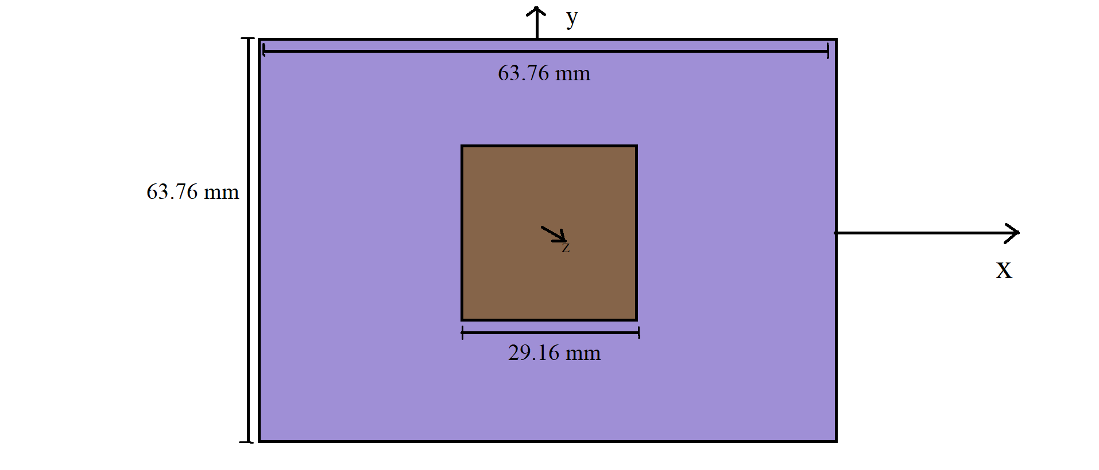
- BLOCK DIAGRAM OF MICROSTRIP ANTENNA

Microstrip or patch antennas are becoming increasingly useful because they can be printed directly onto a circuit board. Microstrip antennas are becoming very widespread within the mobile phone market. Patch antennas are low cost, have a low profile and are easily fabricated.

Consider the microstrip antenna shown in Figure fed by a microstrip transmission line. The patch antenna, microstrip transmission line and ground plane are made of high conductivity metal (typically copper). The patch is of length L, width W, and sitting on top of a substrate (some dielectric circuit board) of thickness h with permittivity permittivity or dielectric constant. The thickness of the ground plane or of the microstrip is not critically important. Typically the height h is much smaller than the wavelength of operation, but should not be much smaller than 0.025 of a wavelength (1/40th of a wavelength) or the antenna efficiency will be degraded.

In antenna design, a patch refers to a flat or planar metallic element that is used as the radiating element of an antenna. The patch is usually a thin, flat piece of conductive material, such as copper or aluminum, that is mounted on top of a dielectric substrate.

The dielectric substrate is a non-conductive material that supports the patch and provides mechanical support for the antenna structure. The substrate material is chosen based on its electrical properties, such as its dielectric constant, loss tangent, and thickness, which affect the performance of the antenna.

The patch is typically fed by a transmission line or a feedline, which is connected to the patch at one or more points. The feedline is used to deliver the radio frequency (RF) signal to the patch, which converts the electrical energy into electromagnetic waves that are radiated into space.

The size, shape, and material of the patch and substrate, as well as the position and impedance of the feedline, all affect the performance of the antenna, including its frequency response, radiation pattern, and polarization. These parameters are typically optimized using electromagnetic simulation tools to design an antenna that meets the desired specifications for a specific application.

2.3 Requirements

2.3.1 Software requirements:

This section should contain a list of expected software required to implement the proposed project idea. You are advised to preferably use open source software.
1)HFSS :
To design the antenna and fabricate it.

2.3.2 Hardware requirements:

We have to build PCB which can demonstration circuit antenna designing.
It need all the hardware requirements to build the PCB in which Majorly include
- PCB
- Connector
- Patch
- Substrate material FR4
- Simulation Output of designed architecture can be seen on HFSS Software as well as

2.4 Selection of Major Components

A patch antenna is a type of antenna with a low profile, which can be mounted on a surface. It consists of a planar rectangular, circular, triangular, or any geometrical sheet or "patch" of metal, mounted over a larger sheet of metal called a ground plane. They are the original type of microstrip antenna described by Howell in 1972.
The two metal sheets together form a resonant piece of microstrip transmission line with a length of approximately one-half wavelength of the radio waves. The radiation mechanism arises from fringing fields along the radiating edges. The radiation at the edges causes the antenna to act slightly larger electrically than its physical dimensions, so in order for the antenna to be resonant, a length of microstrip transmission line slightly shorter than one-half the wavelength at the frequency is used. The patch antenna is mainly practical at microwave frequencies, at which wavelengths are short enough that the patches are conveniently small. It is widely used in portable wireless devices because of the ease of fabricating it on printed circuit boards. Multiple patch antennas on the same substrate (see image) called microstrip antennas, can be used to make high gain array antennas, and phased arrays in which the beam can be electronically steered.
A variant of the patch antenna commonly used in mobile phones is the shorted patch antenna, or planar inverted-F antenna (PIFA). In this antenna, one corner of the patch (or sometimes one edge) is grounded with a ground pin. This variant has better matching than the standard patch. Another variant of patch antenna with the partially etched ground plane, also known as printed monopole antenna, is a very versatile antenna for dual-band operations

Chapter 3

System Design

Antenna designing Mainly done with 4 Operations.
- Calculation
- Designing
- Resonating frequency which we will be required.
- Fabrication

The calculation part of antenna designing involves several steps to determine the dimensions, feed point location, and other parameters of the antenna design. Here are some of the key calculation steps involved in antenna designing:
- Frequency selection: The first step is to select the operating frequency range of the antenna based on the application requirements. This determines the wavelength of the signal and the size of the antenna.
- Antenna geometry: Once the frequency range is determined, the dimensions and shape of the antenna are selected based on the desired performance characteristics. For example, a patch antenna typically consists of a metallic patch mounted on top of a dielectric substrate, and the dimensions of the patch and substrate are chosen based on the desired resonant frequency, bandwidth, and radiation pattern.
- Impedance matching: The impedance of the antenna must be matched to the impedance of the feedline or transmission line to ensure efficient power transfer between the antenna and the transmitter or receiver. This can be achieved by adjusting the dimensions of the antenna, the location of the feed point, or by using impedance matching circuits.
- Radiation pattern: The radiation pattern of the antenna is determined by the geometry of the antenna, and it is important to ensure that the pattern is directed towards the desired direction with the required gain and polarization.

CHAPTER 4

Implementation, Testing and Debugging

4.1 Implementation
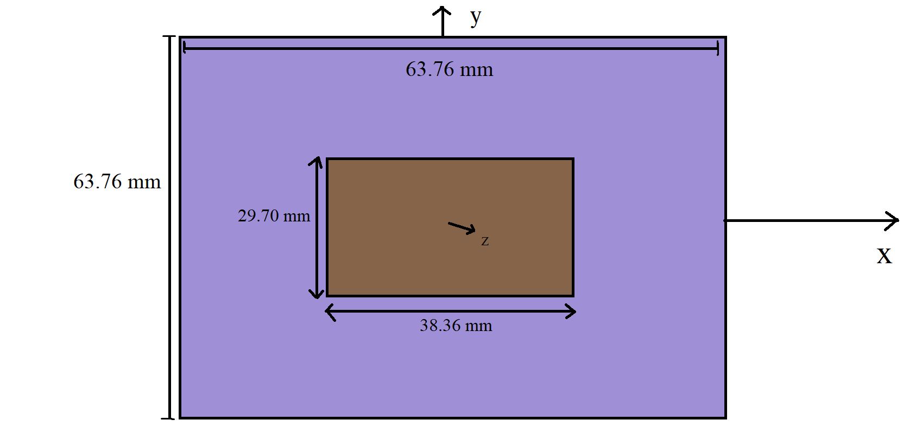
- IMPLEMENTATION OF RECTANGULAR PATCH ANTENNA

4.2 Testing and Debugging
- TESTING OF SQUARE PATCH ANTENNA

4.3 Simulation results
Result loss
- RETURNLOSS GRAPH

Bandwidth
- BW GRAPH

VSWR:

- VSWR GRAPH
Patch Impedance:

- PATCH IMPEDANCE GRAPH

4.4 PCB Design

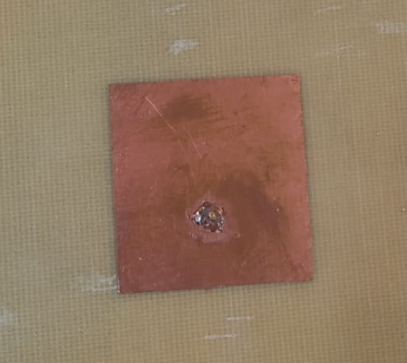

- FRONT VIEW OF ANTENNA
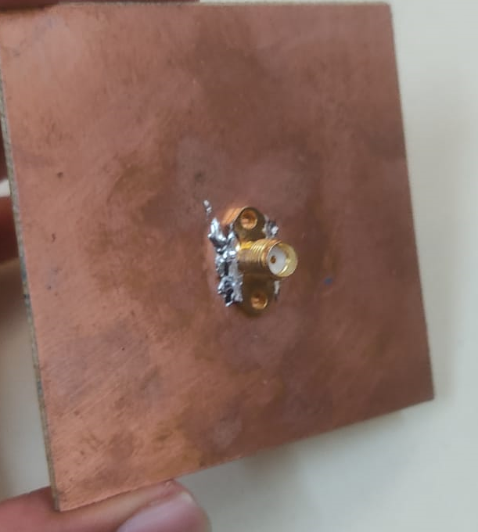

- BACK VIEW OF ANTENNA

4.5 Final Working

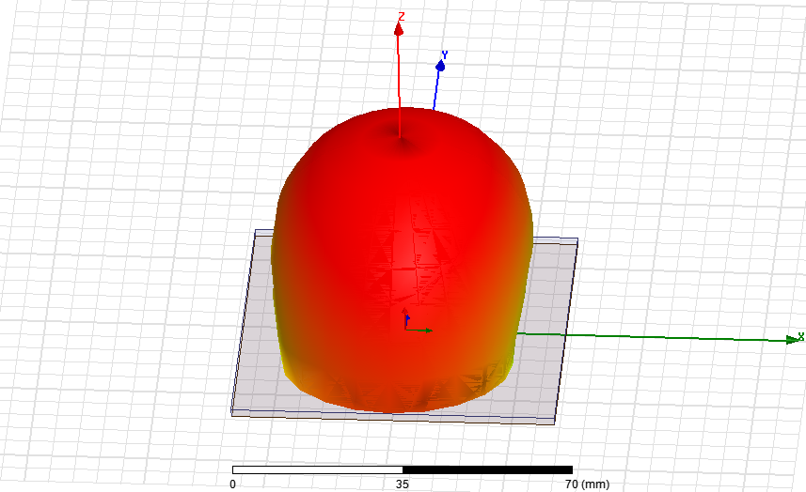
- FINAL WORKING DIAGRAM

CHAPTER 5

Results And Conclusion

Results
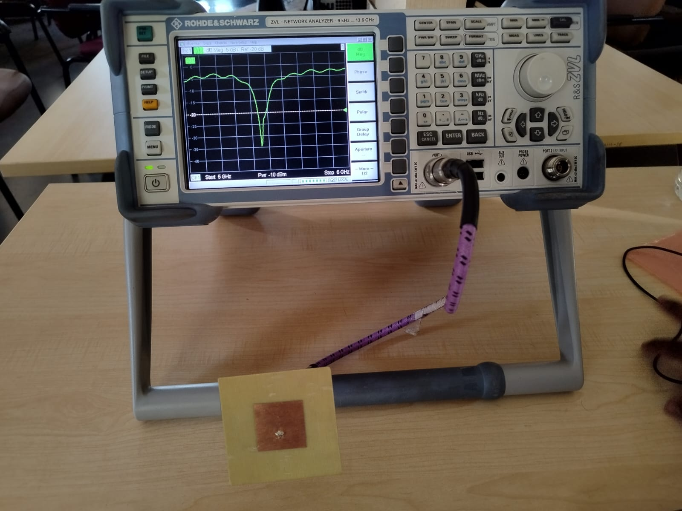
- RETURNLOSS ON VNA -:-35DB
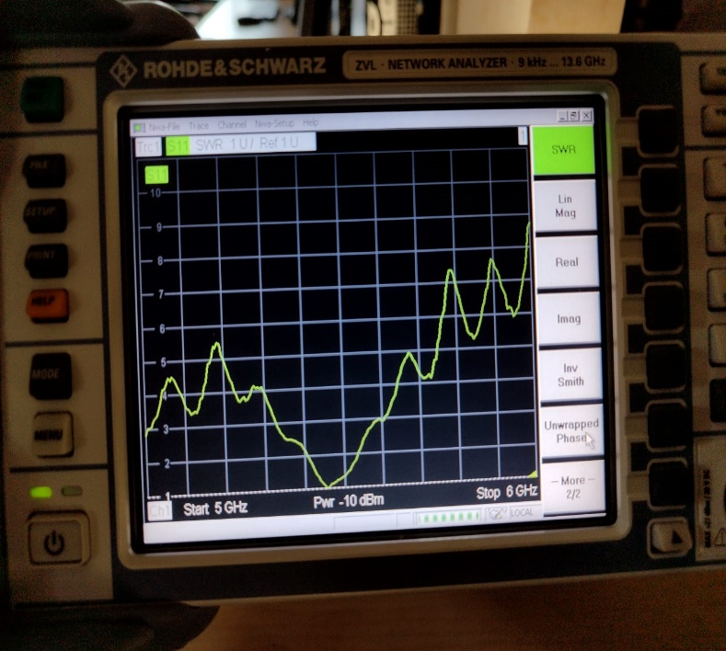
- VSWR ON VNA IS IN PRESCRIBED LIMIT
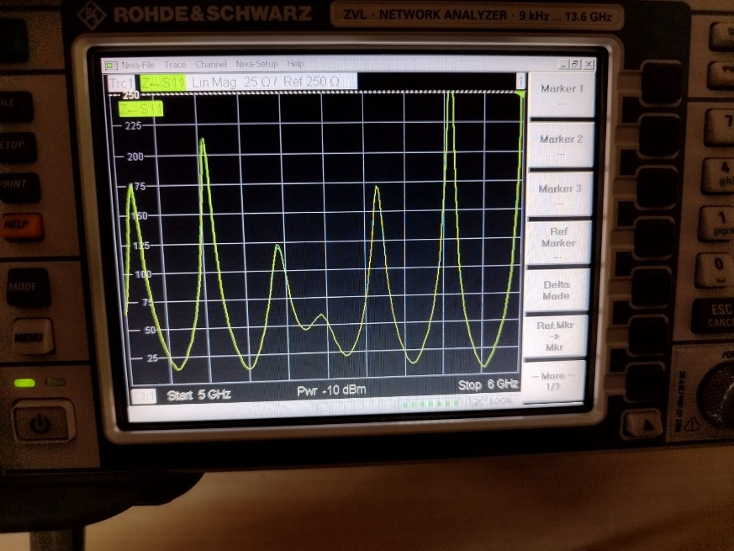
- IMPEDANCE ON VSWR-:50
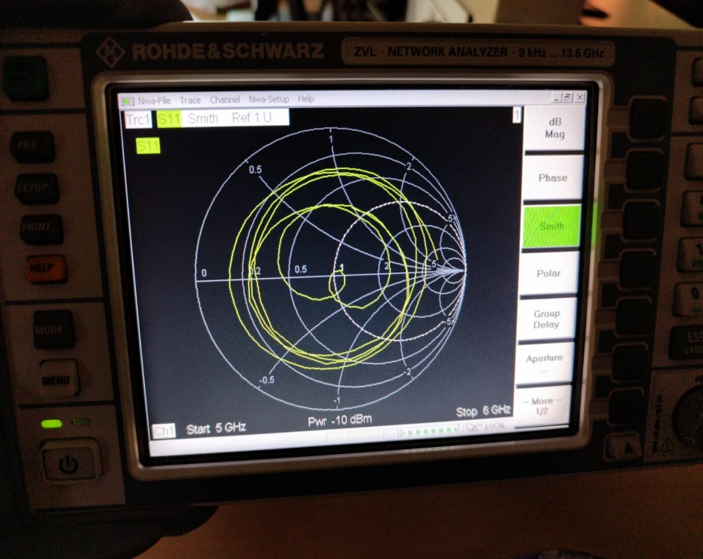
- SMITH-CHART ON VNA

The Vector network analyzer or VNA is an important test instrument that has helped make countless modern wireless technologies possible. Today, VNAs are used in a wide range of RF and high frequency applications. In design applications, simulations are used to accelerate time-to-market by reducing physical prototype iterations. VNAs are used to validate these design simulations. In manufacturing applications, RF components or devices are assembled and tested based on a certain set of specifications. VNAs are used to quickly and accurately validate the performance of these RF components and devices.

Conclusion

Through the use of electromagnetic simulation tools such as HFSS, CST, or FEKO, engineers can analyze the performance of different antenna designs and select the optimal design that meets the desired specifications for the MBAN application.

Overall, the design simulation of an antenna for MBAN application is a critical step in the development of wireless medical devices, as it enables the reliable and efficient transmission of medical data for improved patient care.

5.2 Future Scope

Future Scope includes several possibilities for further optimization and improvement of the antenna design.

One potential avenue for future research is to investigate the use of advanced materials and fabrication techniques to improve the performance of the square patch antenna. For example, using metamaterials or nanomaterials in the construction of the patch and substrate could improve the antenna's bandwidth, efficiency, and radiation pattern.

Another area for future research is to explore different feeding techniques and feeding structures for the square patch antenna. For example, using a probe feed or a coaxial feed could improve the impedance matching and reduce the losses in the feedline.

In addition, future research could focus on improving the miniaturization of the square patch antenna, which is critical for MBAN applications that require small, lightweight, and low-power antennas. One potential approach is to use fractal geometries or other non-conventional antenna shapes to achieve a more compact design.

5.3 References

- Khilare, Sunny, Rishabh Mhatre, Ganesh Kulkarni, Shahadev Hake, and Pune PICT. “ANTENNA DESIGN FOR WEARABLE MEDICAL DEVICES USING MBAN BAND.”
- Zhu, Xiao-Qi, Yong-Xin Guo, and Wen Wu. "Miniaturized dual-band and dual-polarized antenna for MBAN applications." IEEE Transactions on Antennas and Propagation 64, no. 7 (2016): 2805-2814.
- T. -W. Koo, J. -G. Yook, Y. -J. Hong, G. Park and K. Shin, "Low profile patch antenna for on-body wireless sensor application in MBAN band," Proceedings of the 2012 IEEE International Symposium on Antennas and Propagation, Chicago, IL, USA, 2012, pp. 1-2, doi: 10.1109/APS.2012.6349020.
- Bhattacharjee, S., Midya, M., Mitra, M., & Bhadra Chaudhuri, S. (2019). Dual band- dual polarized planar inverted F-antenna for MBAN applications. International Journal of Microwave and Wireless Technologies, 11(1), 76-86.

